CSA0501-DATABASE MANAGEMENT SYSTEMS
LAB EXPERIMENTS DATE:12/07/2026

EXPERIMENT 3 -- DML Commands (INSERT, SELECT)
AIM:
To perform Data Manipulation Language (DML) commands such as INSERT and SELECT in the Flight Reservation System tables.
PROCEDURE:
1. Open MySQL Workbench and select the Flight_Reservation database.
2. Create the Passenger, Flight, Booking, Airport and Payment tables.
3. Use INSERT to populate all five tables with sample records.
4. Use SELECT to retrieve records from each table.
5. Verify the inserted data.
6. Observe the output of each query.
PROGRAM:
1. INSERT INTO Passenger
INSERT INTO Passenger
VALUES
(101,'Arun',25,'M','arun@gmail.com'),
(102,'Priya',22,'F','priya@gmail.com');
SELECT * FROM Passenger;

OUTPUT:
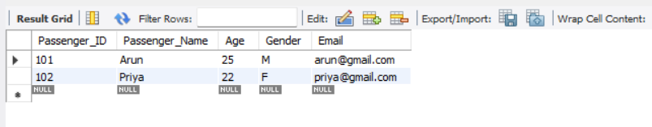

2. INSERT INTO Flight
INSERT INTO Flight
VALUES
(201,'IndiGo','Chennai','Delhi','10:30:00',6500.00),
(202,'Air India','Chennai','Mumbai','02:15:00',7200.00);
SELECT * FROM Flight;

OUTPUT:
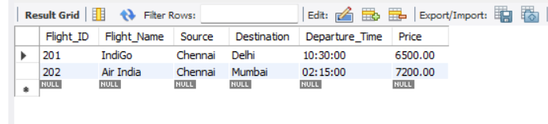

3. INSERT INTO Booking
INSERT INTO Booking
VALUES
(301,101,201,'2026-07-27'),
(302,102,202,'2026-07-28');

SELECT * FROM Booking;

OUTPUT:
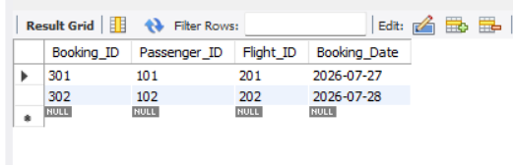

- INSERT INTO Airport

CREATE TABLE Airport (
Airport_ID INT PRIMARY KEY,
Airport_Name VARCHAR(100),
City VARCHAR(50)
);
INSERT INTO Airport
VALUES
(1,'Chennai International','Chennai'),
(2,'Indira Gandhi International','Delhi');
SELECT * FROM Airport;

OUTPUT:
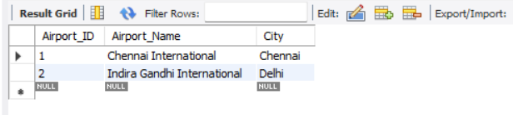

5. INSERT INTO Payment
INSERT INTO Payment
VALUES
(501,301,'UPI',6500.00),
(502,302,'Card',7200.00);

SELECT * FROM Payment;
OUTPUT:
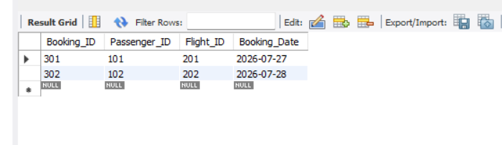
6. VIEW ALL TABLES
SELECT * FROM Passenger;
SELECT * FROM Flight;
SELECT * FROM Booking;
SELECT * FROM Airport;
SELECT * FROM Payment;
OUTPUT:
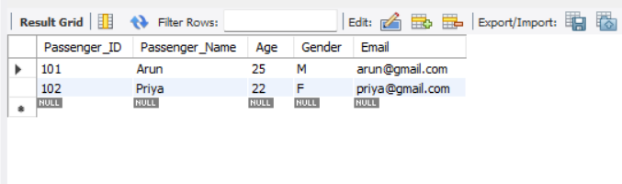
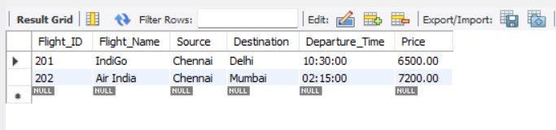
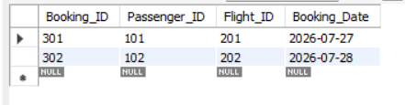
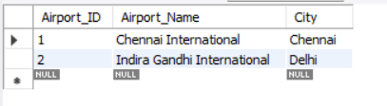
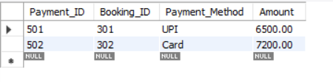

RESULT:
Thus the Data Manipulation Language (DML) commands such as INSERT and SELECT were successfully executed and verified in the Flight Reservation System.

